International Conference on
Sustainable Energy Technologies and Computational Intelligence
(SETCOM 2025)
Department of Electrical Engineering, SoET
Pandit Deendayal Energy University (PDEU), Gandhinagar, Gujarat, India |

February 21 – 23, 2025

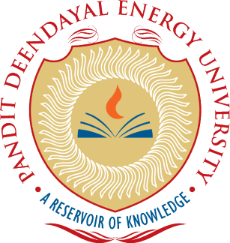

SETCOM 2025 Special Sessions on

“Title of the special session”

Aims & Scope of the Session (100-200 words):

Topics of interest include, but are not limited to:
A list of 5-10 relevant areas under proposed theme of special issue

Special Session Organizers (names and contact emails):
(Maximum two members)

Potential Reviewers (names and emails):
(If any)

Special Session Organizers (short bios with photo):

Photo | Bio
Photo | Bio

